Reviewer's Comments:

Reviewer: 1

Comments to the Author

The paper presents numerical analyses on the stability properties of multi-body systems with and without the inclusion of friction. Qualitatively, the manuscript's subject is novel and it provides a handful of insights that can be useful to the community. However, quantitatively the paper is rather confused, as it seems hard to obtain much useful information out of it. Specifically, the authors introduce many quantities, some of which are well defined, some of which are a bit more arbitrarily defined. The analytical part of the paper is also rather unconvincing, and could probably be moved to an Appendix. For these reasons I believe a revision is necessary. Still, some of the results presented here can be a first step to a better understanding of the stability properties of multi-body systems with dissipation. I suggest that the authors attempt to present the subject more clearly, choosing fewer but more significant quantities to describe the outcome of the simulations, and be more straightforward about the possibility of applying these results in given astrophysical problems.

I articulate on these points below.

Main comments:

1) Fig 1 and Fig 2: I think Figure 2 actually shows quite convincingly that the "gray area" classification (<4% vs >96% stability) is pretty arbitrary: there is no sharp change in instability timescale at the crossing of the "gray area" boundaries, unlike the crossing of the K_syn boundary, which is however completely invisible in Figure 1.

A similar point can be made for figures 11 and 12.

Based on this comment, we change the classification of grey zones to “>10% & <90% stability). The grey areas in Figures 1, 4, 6 and 11 now cover the transition region much more tightly.

We think both K_gz and K_syn are important:

(i) As the reviewer has pointed out, K_syn corresponds to the location where the timescale changes. (ii) K_gz represents the ‘beginning of the onset’ to stability. The point of K_gz and K_crit is to show that the boundary between stability and instability can be broad, which is also a main result of this paper.

2) Section 3.3 attempts to investigate what is happening in these cases (resonances are acting as a protecting mechanism against close encounters). But the presence of a strong instability at the location of a mean motion resonance later on in Figure 11 shows that it is not really clear from this work what the overall role of resonances is in terms of causing (in)stability. If in Figure 9 and 10 some angles are shown to be librating, could the authors show what happens to the corresponding angles in Fig 11 where systems are actually unstable close to mean motion resonances?

We show the two example liberations to illustrate that these stability islands may possibly be related to mean-motion resonances, but it is not clear whether this kind of resonances can explain all complexities in the grey zones.

We have moved the resonance analysis to the appendix to avoid distraction and over-interpretation.

3) In Figure 6, I don't see why the authors claim that there is any resemblance with Figure 2. Neither the gray areas nor the vertical blue lines have any corresponding feature in the Figure at those locations. In any case, it would help to mark here the quantity called K_{crit,e}.

Moreover, by looking at the top plot for mu=1.e-6, one could easily imagine that even for K>5 there could be runs where the eccentricity destabilisation times are again "finite" (i.e. less than the chosen value of 1.e5*P1), since the features observed in the plot are very close to the chosen limit K=5. This essentially means that K_{crit,e} for mu=1.e-6 could actually be larger than 5. Again, there does not seem to be any clear correlation with K_{crit}, so I don't understand why the authors write that the two quantities are "closely related" (Page 6 line 254). All in all, it is not really clear what the role of the quantity K_{crit,e} is.

We agree with the reviewer’s comment that results from the map and the N-body simulations present many differences. Some of these differences (such as the finite t_e at K~5 for the mu=1.e-6 runs) are actually related to the “stability criteria” that the reviewer mentioned in comment #4. We shall elaborate more in our response to comment #4.

As for the “similarity” between the map and the N-body simulations, what we want to highlight is that: (i) t_e and t_inst both show large spread and the average t_e grow exponentially with K; (ii) the map and the N-body simulation both show stability islands; (iii) they have stabilisation conditions t_e<\tau and t_inst<\tau.

To incorporate the reviewer's comment, we have slightly redescribed the map result. Now the detailed similarities are highlighted and the differences are also addressed.

4) There is a bit of confusion about the "stability criteria" used for the N-body simulations and for the map. For the N-body runs, the condition used is (3) which makes sense. For the map, eq (24) is used, and according to the authors this condition has to replace the one used for N-body simulations since the latter violates the validity range of the map. Firsly, I would argue that this statement could be clarified: in what way is the validity range of the map violated?

Moreover, the condition (24) could in principle be applied to N-body simulations too, at least as a check for the sole purpose of making the comparison between N-body and map simulations more straightforward. However, I fear that the condition (24) applied to the N-body runs will show different results than condition (3) because condition (3) depends on mu^(1/3) (which changes by 1 order of magnitude for the mass range used in the paper), while (24) does not.

Have the authors checked this? If my fear is confirmed then it's hard to understand why the map and its stability condition (24) should help understanding what is happening in the N-body simulations with stability condition (3).

The iterative map is derived for e<<epsilon, so the map can be accurately

5) Page 8 section 4: I do not understand the choice of mass distribution in the planetary system. Most results in the literature have been obtained for equal-mass planets. Here the planets get less and less massive as one moves out. Why has this choice been made?

This choice is strange also in terms of applicability to real-life planetary systems, as they appear to exhibit intra-system uniformity in mass.

We agree with the reviewer that mass distribution among planets can affect the results. We did not construct systems with uniform intra-system mass distribution because we think the results of this paper apply not only to planet systems, but also to other orbital systems (e.g., black holes in AGN discs around supermassive black holes).

In the new Section 4.4, we show simulation results for systems with three equal-mass planets. The results are similar to those of unequal-mass planets, especially with \mu is small.

Further exploration of the mass-distribution dependence of stability is beyond the scope of this paper, and may be considered in a future study.

6) Eq (6) indeed implements e-damping, but since it is a radial force it exerts no torque meaning that the angular momentum L=sqrt(a(1-e^2)) is conserved by this frictional force. Thus, every time a particle gains eccentricity from interactions with the planet and its e is damped at constant L, its semi-major axis changes as well (i.e. the particle should migrate. See e.g. eq. A.16 from Ataiee&Kley2021, setting tau_L=0 in this case shows that there is a non-vanishing tau_a for a given tau_e; depending on the value of e, this timescale can be close to tau_e within an order of magnitude, while it should be relatively unimportant at small e's). Is this effect wanted by the authors? It is not really mentioned in the discussion. Also, this effect is not incorporated in the map (eqs 20-22), where only the complex eccentricity is damped.

By the way, this might be why adding this frictional force destroys the "islands of stability" (Figure 3, black vs coloured lines): the particles are migrating to smaller K values and thus becoming unstable. Have the authors checked this?

I have not checked this. I think this is a small effect in our runs because our e is always less than the so-called Hill eccentricity. I will check this. (??!!)

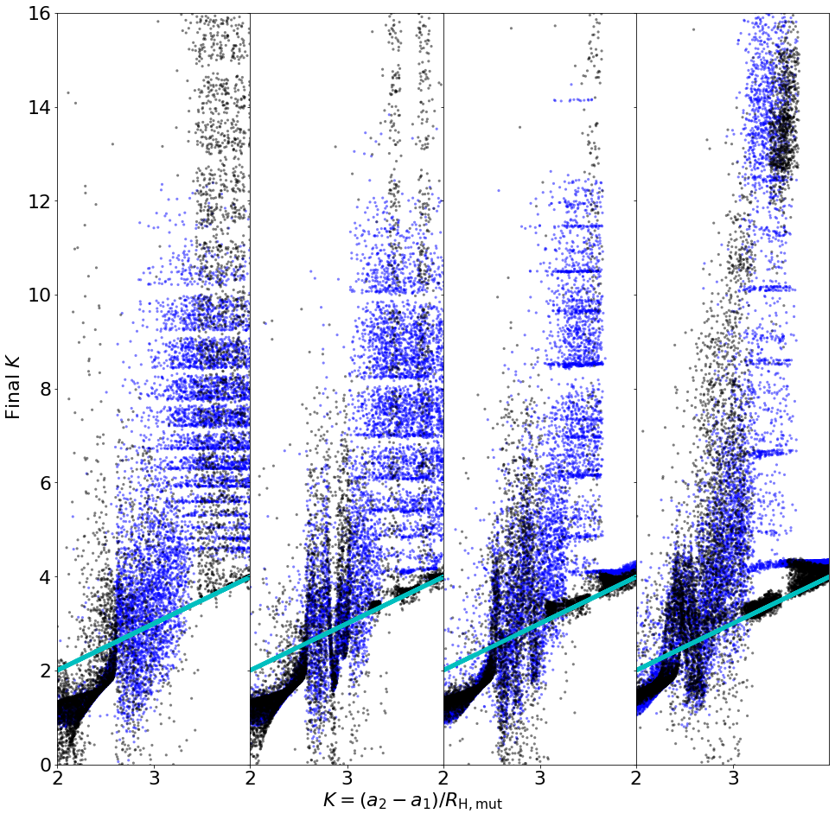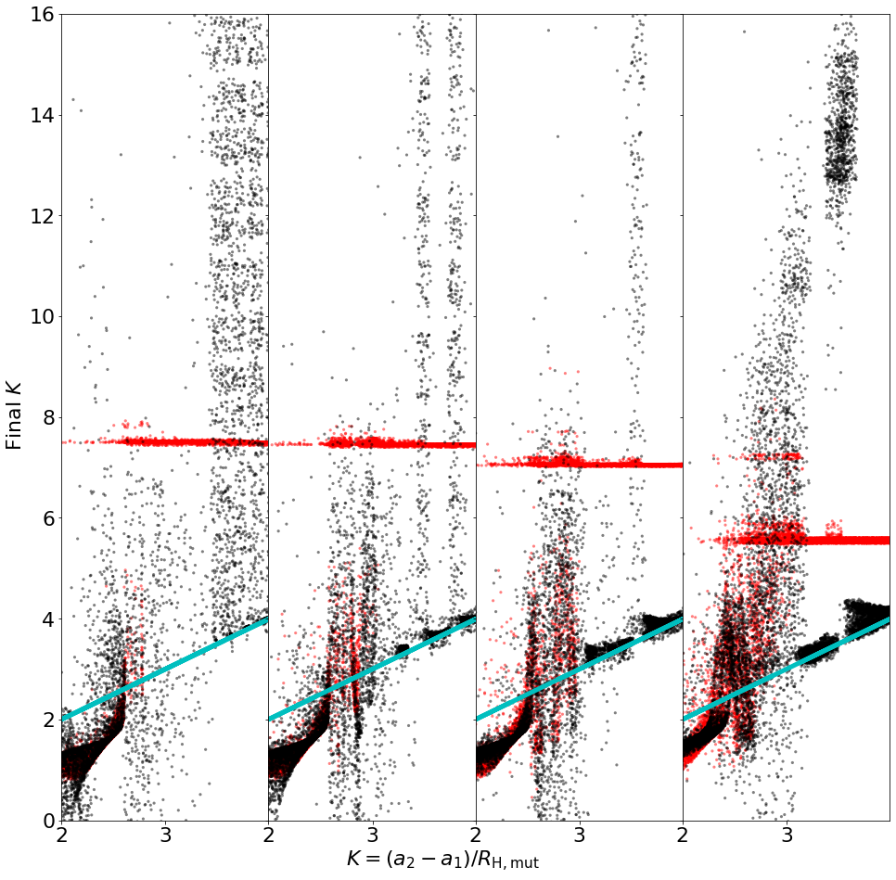

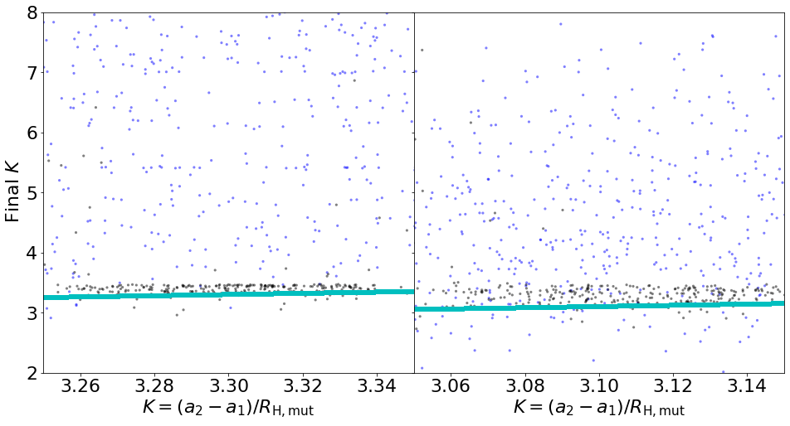

7) Linked to this point is the fact that the authors introduce (with good reason) the presence of closely packed systems by invoking orbital migration, but the effects of migration (the torque) on the planetary systems actually evolved in the paper are completely ignored. I think this choice should somehow be justified somewhere in the paper.

Point 6 and point 7 are actually related. If I understand correctly, the reviewer wants us to discuss the effect of orbital migration to the stability of a planetary system.

8) The conclusions in sect 5.1 are presented clearly but they do seem a bit weak. The conclusions for the systems without friction add little to the information already contained in multiple papers on the subject. The main conclusion for the systems with friction is that the friction timescale must be shorter than the instability time (or a multiple of it, depending on the number of planets) for the frictional force to ensure the stabilisation of the system. But it is said earlier that the instability time can vary by orders of magnitude for a system with the same mu and K. This means that in a practical scenario where one wants to know if a given system will be stable in the presence of a given level of frictional forces, the manuscript provides no clear information on the answer, and one will have to resort to simulations anyway. In addition, the second main result on systems with friction is that frictional forces may actually render unstable systems that were previously stable: this adds to the limitations in terms of the applicability of the paper, and the origin of this effect is not investigated in the paper.

Given that the main novelty of the paper is on the stability properties of systems with friction, this shows a major limitation to the applicability of this work.

Unless I am missing something, I believe this should be stressed more clearly in the conclusions of the paper.

Based on the reviewer’s comment, we have reorganised the concluding section (see the text in red).

Now, in 5.1, we first describe our main results: boundaries for stabilities. Then, we describe how stability relates to t_inst and \tau. Finally, we mention the complexity of the stability islands.

In 5.2, we add a paragraph about how our results may be used.

Minor comments:

A) Page 9: I find the introduction of the quantities K_\tau^* and \tilde{K_\tau} a bit confusing. I suggest rephrasing this passage.

B) Pg 8 Line 337: what does it mean "For some experiments, we apply equation (6)"? Which experiments?

C) Pg 2 Line 53: The works of Pichierri&Morbidelli2020 and Goldberg+2022 should be mentioned here; in particular Goldberg+2022 does a better job at predicting stability than Tamayo+2020.

D) Eq (4) depends on the absolute orbital periods of the two bodies, while instead every other quantity (K, t_inst etc) is presented as a scale-independent quantity. This creates confusion as T_syn as it is now defined cannot just depend on K (which is a scale-free quantity). I suggest to define T_syn in units of P_1, which is how it's presented in Table 2, or to clarify the dependence on the orbital parameters.

E) Figure 6 shows "gray zones" from the N-body simulations, while Figure 8 shows "gray zones" for particles "evolved using the map". However, in the text (line 256 P 6) the two figures are mentioned together. So it can be a bit confusing to follow which gray zones convey which information.